My Native Plant Wish List |  |  |  |  | 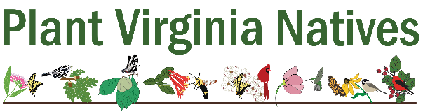
Garden Visited  (or Online/Magazine Source) |  |  | Garden Type  (e.g., Sun, Shade, Pollinator, Water-Wise) |  |  | URL/Site Address  (for future reference as desired)
1.
2.
3.
4.
5.
6.
7.
8.
Plants I Liked:  (include botanical name if known) |  |  |  | What I Liked About Them:  (e.g., height, color, leaf shape, host plant, bloom time)
1.
2.
3.
4.
5.
6.
7.
8.
9.
10.
11.
12.
13.
14.
15.
 |  | Native Plants Already on Site that will Factor into the Garden Design):
1.
2.
3.
4.
5.
6.
7.
8.
9.
10.
Continues on Next Page

My Native Plant Wish List (Continued)
Final Candidates (Add Details to Help with Final Selections)
 | Plant Name | Larval Host? | Value  to: | Preferred |  |  |  | Mature Height |  | Mature Width | Habit¹ | Spread by:² | Bloom Color | Bloom Time | Fruit-Bearing?³ | #  Desired
 |  |  |  | Sun | Soil | Moisture
Example | Lindera benzoin  Northern Spicebush | Yes | Birds, Butterflies | Full or  Part Shade | Sandy | Moist, well drained |  | 6–12’ |  | 8–12’ | Broad, rounded | Seeds or Softwood Cuttings | Yellow | March-April | Yes; need male and female | 3
Plants I Intend to Retain
(Transfer from
Page 1)
New
Plants
¹ Noting details from plant profiles can help you picture the form and shape of the plant’s growth. Look for words like upright, oval, pyramidal, columnar, spreading, broad spreading, weeping, clumping, shrubby, or vase-shaped.
² Noting how the plant primarily reproduces--such as by seeds or rhizomes (creeping rootstalks) helps you anticipate how it will behave in the garden. Some plants that spread by rhizomes can be too aggressive for small garden beds, potentially crowding out other plants (think of mints). Gardeners can choose to place such plants in locations that allow for their spreading habits or plan how they will curb unwanted spread (e.g., by planting them in containers, using edging to prevent root spread, or other means).
³ Noting if a plant is dioecious (a species whose male and female organs occur on separate individuals) will help you remember you need both male and female plants for the plant to bear fruit.

